SPRINT-4

**MIT-INVENTOR**

|  |  |
| --- | --- |
| Date | 17 November 2022 |
| Team ID | PNT2022TMID44638 |
| Project Name | HAZARDOUS AREA MONITORING FOR INDUSTRIAL PLANT POWERED BY IOT |
|  |

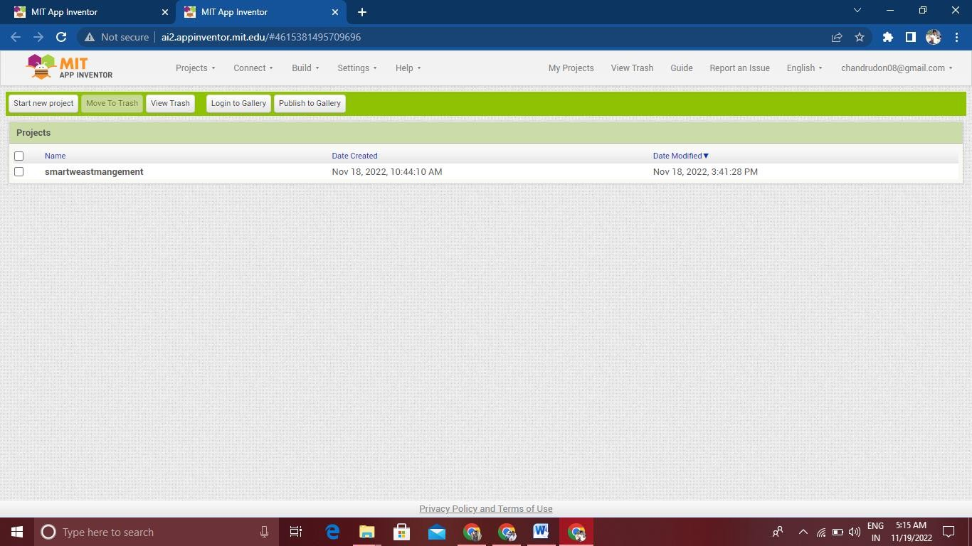

SCREEN 1

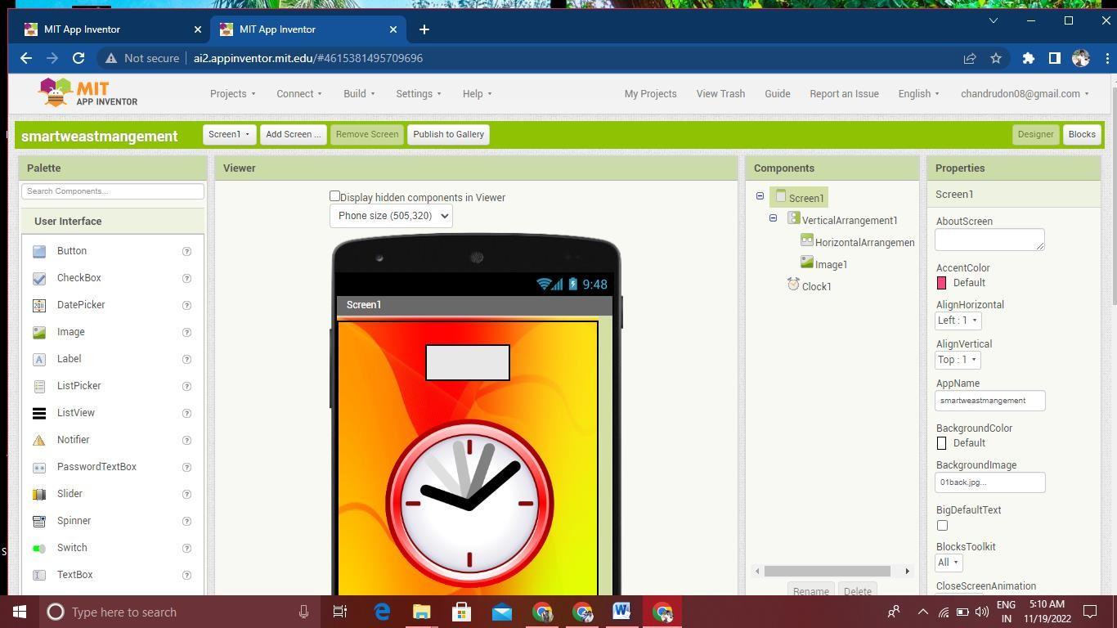

.

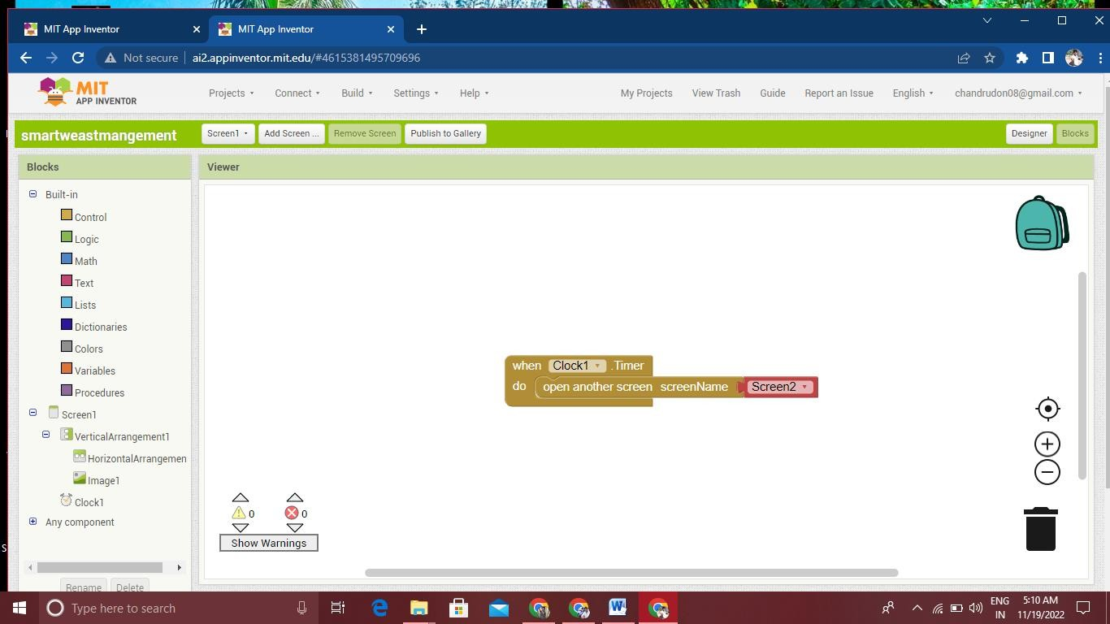

SCREEN 2

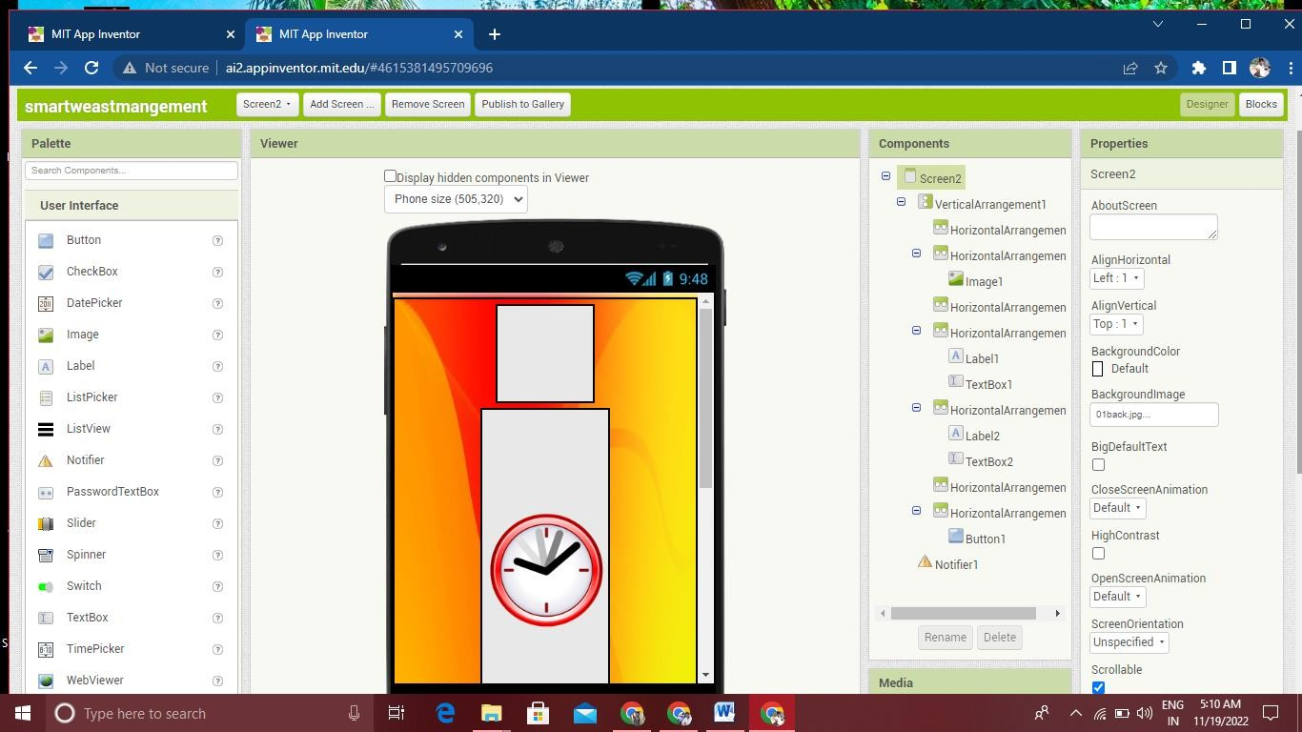

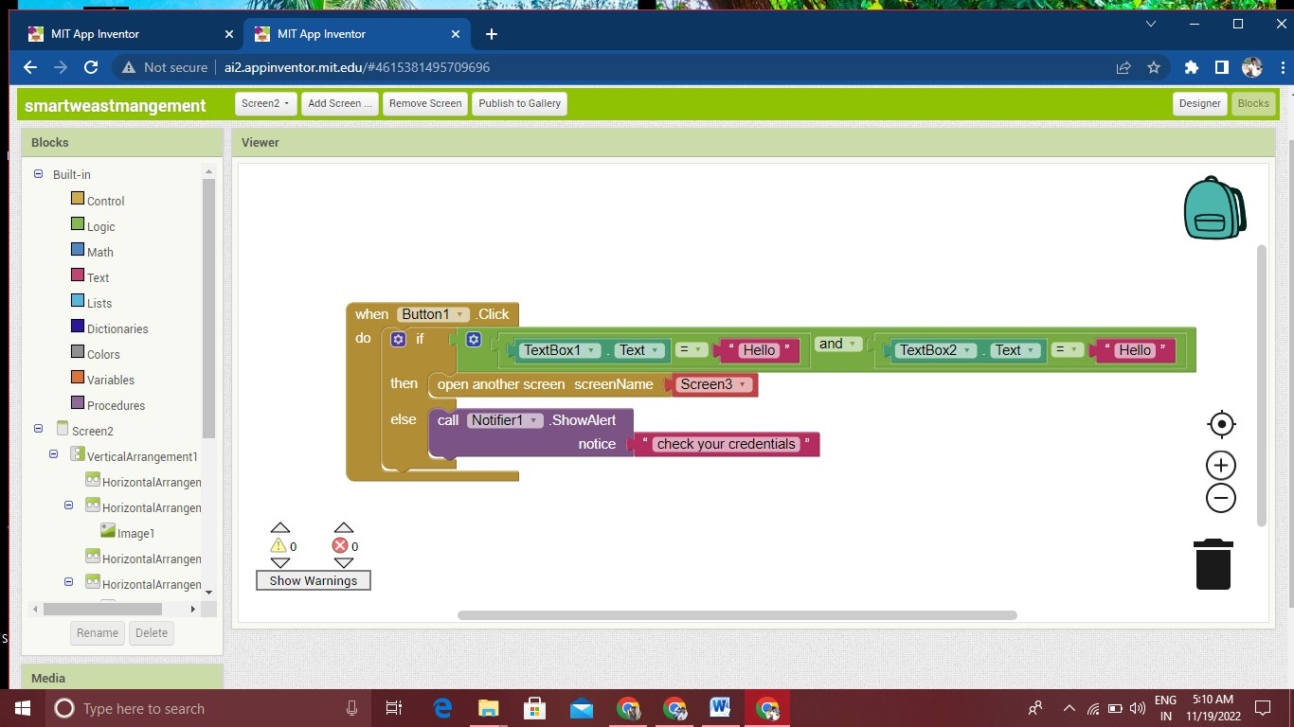

SCREEN 3



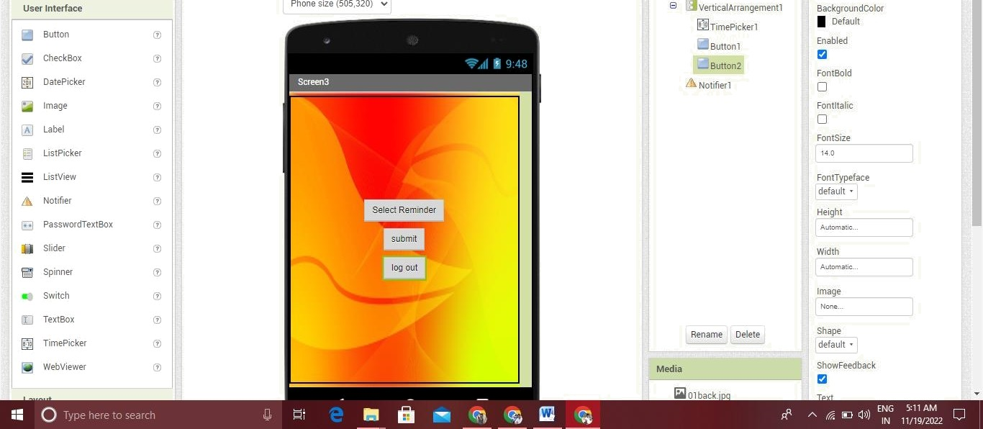%Dispa¿WddencomponentsinViewer O—  Butto n2

